**DAILY ONLINE ACTIVITIES SUMMARY**

|  |  |  |  |  |  |  |  |  |
| --- | --- | --- | --- | --- | --- | --- | --- | --- |
| **Date:** | **22/05/2019** | | | | | **Name:** | **Varshitha Makam** | |
| **Sem & Sec** | **8th B** | | | | | **USN:** | **4AL16CS118** | |
| **Online Test Summary** | | | | | | | | |
| **Subject** | | **BDA** | | | | | | |
| **Max. Marks** | | **40** | | **Score** | | | **30** | |
| **Certification Course Summary** | | | | | | | | |
| **Course** | **Introduction To Hadoop** | | | | | | | |
| **Certificate Provider** | | | **GreatLearning** | | **Duration** | | | **8 mins** |
| **Coding Challenges** | | | | | | | | |
| **Problem Statement:** | | | | | | | | |
| **Status: Completed** | | | | | | | | |
| **Uploaded the report in Github** | | | | | **yes** | | | |
| **If yes Repository name** | | | | | **varshithamakam** | | | |
| **Uploaded the report in slack** | | | | | **yes** | | | |

Online Test Details:

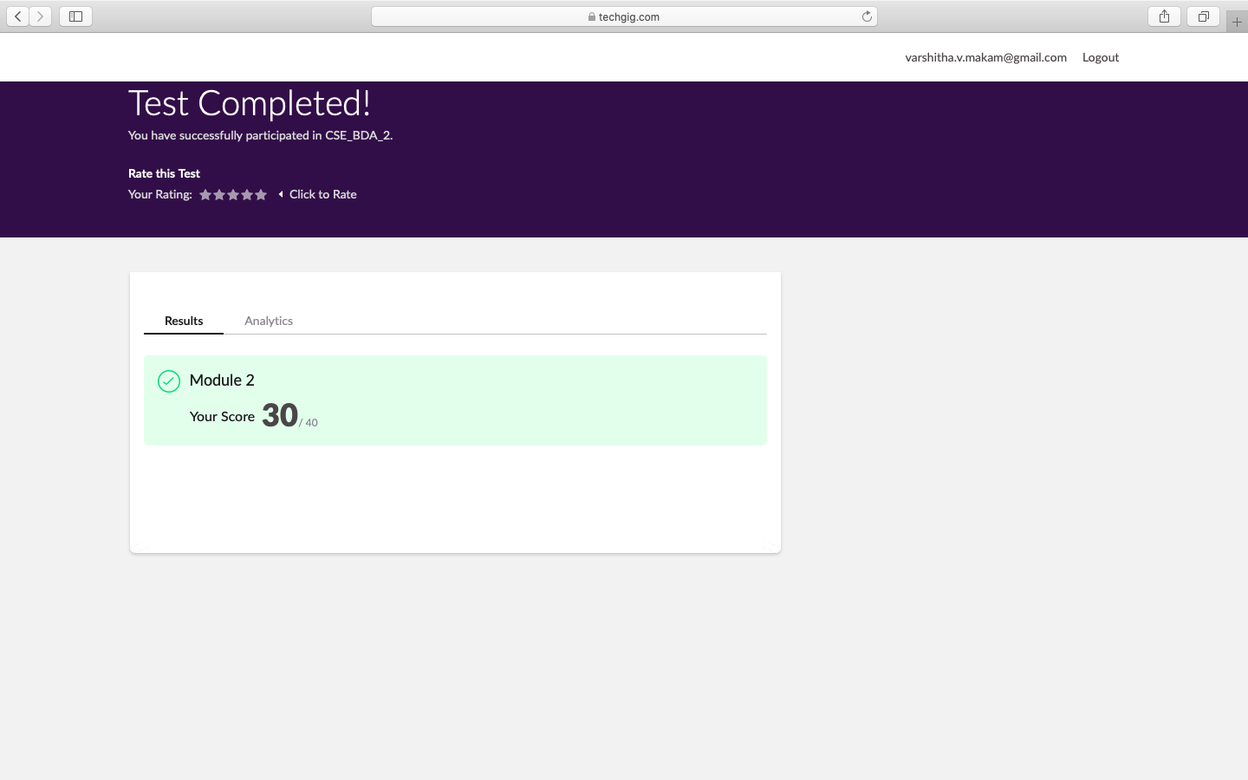

Certification Course Details:

Organizations can optimize IoT data, quickly and cost-effectively deriving its business value by developing expertise in ETL (extract, transfer, load) technologies, such as stream processing and data lakes.

At many organizations, though, this may lead to IT bottlenecks, long project delays, and data science being deferred. Result: IoT projects – in which predictive analytics data is meant to play a critical role in improving operational efficiency and spurring innovation – *still* haven’t crossed the proof-of-concept threshold and definitely cannot demonstrate ROI.

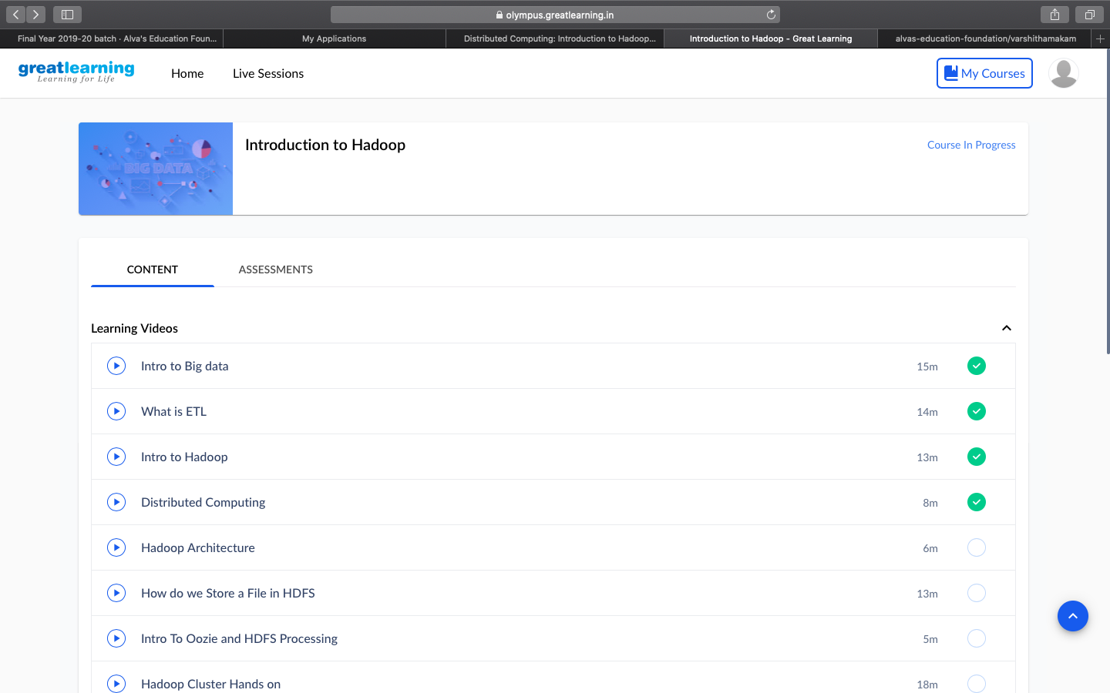

Coding Challenges Details:

#include <stdio.h>  
#include <stdlib.h>

struct node  
{  
int info;  
struct node *ptr;  
}*top,*top1,*temp;

int topelement();  
void push(int data);  
void pop();  
void empty();  
void display();  
void destroy();  
void stack_count();  
void create();

int count = 0;

void main()  
{  
int no, ch, e;

printf("\n 1 - Push");  
printf("\n 2 - Pop");  
printf("\n 3 - Top");  
printf("\n 4 - Empty");  
printf("\n 5 - Exit");  
printf("\n 6 - Dipslay");  
printf("\n 7 - Stack Count");  
printf("\n 8 - Destroy stack");

create();

while (1)  
{  
printf("\n Enter choice : ");  
scanf("%d", &ch);

switch (ch)

{

case 1:

printf("Enter data : ");

scanf("%d", &no);

push(no);

break;

case 2:

pop();

break;

case 3:

if (top == NULL)

printf("No elements in stack");

else

{

e = topelement();

printf("\n Top element : %d", e);

}

break;

case 4:

empty();

break;

case 5:

exit(0);

case 6:

display();

break;

case 7:

stack_count();

break;

case 8:

destroy();

break;

default :

printf(" Wrong choice, Please enter correct choice ");

break;

}

}  
}

/* Create empty stack */  
void create()  
{  
top = NULL;  
}

/* Count stack elements */  
void stack_count()  
{  
printf("\n No. of elements in stack : %d", count);  
}

/* Push data into stack */  
void push(int data)  
{  
if (top == NULL)  
{  
top =(struct node )malloc(1sizeof(struct node));  
top->ptr = NULL;  
top->info = data;  
}  
else  
{  
temp =(struct node )malloc(1sizeof(struct node));  
temp->ptr = top;  
temp->info = data;  
top = temp;  
}  
count++;  
}

/* Display stack elements */  
void display()  
{  
top1 = top;

if (top1 == NULL)  
{  
printf("Stack is empty");  
return;  
}

while (top1 != NULL)  
{  
printf("%d ", top1->info);  
top1 = top1->ptr;  
}  
}

/* Pop Operation on stack */  
void pop()  
{  
top1 = top;

if (top1 == NULL)  
{  
printf("\n Error : Trying to pop from empty stack");  
return;  
}  
else  
top1 = top1->ptr;  
printf("\n Popped value : %d", top->info);  
free(top);  
top = top1;  
count--;  
}

/* Return top element */  
int topelement()  
{  
return(top->info);  
}

/* Check if stack is empty or not */  
void empty()  
{  
if (top == NULL)  
printf("\n Stack is empty");  
else  
printf("\n Stack is not empty with %d elements", count);  
}

/* Destroy entire stack */  
void destroy()  
{  
top1 = top;

while (top1 != NULL)  
{  
top1 = top->ptr;  
free(top);  
top = top1;  
top1 = top1->ptr;  
}  
free(top1);  
top = NULL;

printf("\n All stack elements destroyed");  
count = 0;